Student Name ________________________________

Activity 2.3 - Maslow's Hierarchy of Needs

Instructions: Open MS Word.

1. Create a new document.
2. Save your document as Maslow's Hierarchy of Needs
3. Type your name at the top of the page.
4. Insert a Smart Art
5. Choose the Pyramid Chart Style
6. Create and label all 5 levels of Maslow's Hierarchy of Needs
7. When done, save and share to [tellsworth@fillmorecsd.org](mailto:tellsworth@fillmorecsd.org) when done.

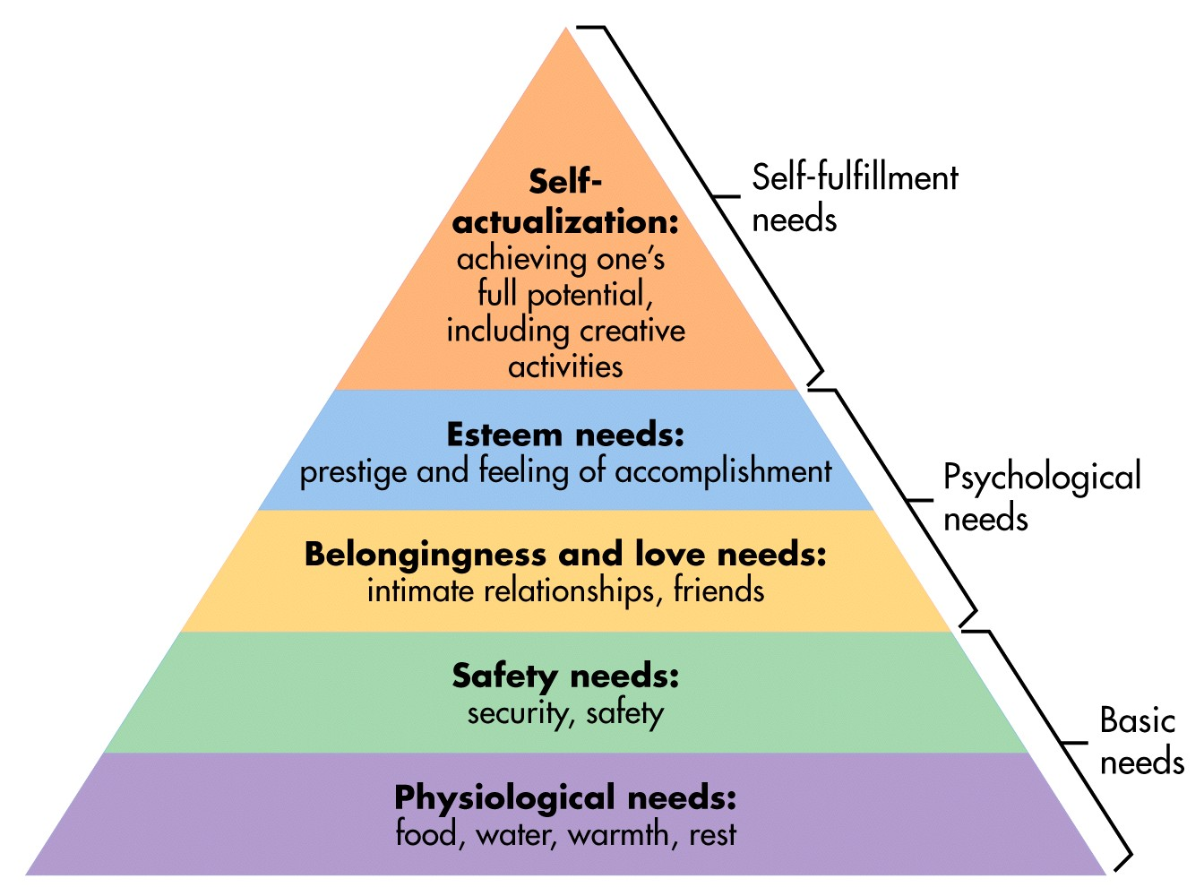

[This Photo](http://worldbuilding.stackexchange.com/questions/10645/what-would-poverty-be-like-if-there-was-an-infinite-supply-of-food) by Unknown Author is licensed under [CC BY-SA](https://creativecommons.org/licenses/by-sa/3.0/)